To execute the tests, please run the Test Runner file which is in the below path

**/Test_Automation/src/test/java/com/sr2/runner/TestRunner.java**

**Scenarios Covered:**

@regression  
**Feature:** purchase item  
  
 **Scenario:** Adding to bakset and purchase  
 **Given** I am on My Store form  
 **When** I login as registered user email "**rtqdl@kqhuh.com**" and password "**jonnyhiles**"  
 **Then** I should be able to login successfully  
 **When** I add first item to the cart from the dresses section  
 **And** Proceed to checkout with the default delivery address  
 **And** I accept the terms and conditions for Shipping  
 **And** select payment method as "**Bank-wire payment**"  
 **And** I confirm my order  
 **Then** I should see my order is created successfully  
  
 **Scenario:** Adding items using quick view to bakset and change size, color and purchase  
 **Given** I am on My Store form  
 **When** I login as registered user email "**rtqdl@kqhuh.com**" and password "**jonnyhiles**"  
 **Then** I should be able to login successfully  
 **When** I add first item to the cart from the summer dresses section  
 **And** Proceed to checkout with the default delivery address  
 **And** I accept the terms and conditions for Shipping  
 **And** select payment method as "**Bank-wire payment**"  
 **And** I confirm my order  
 **Then** I should see my order is created successfully  
  
 **Scenario:** Login Unsuccessfully  
 **Given** I am on My Store form  
 **When** I login with unregistered user email "**Robert@Smith.com**" and password "**RobertSmith**"  
 **Then** I should throw Authentication failed error  
  
  
  
 @regression  
**Feature:** Register user login successfully  
  
 **Scenario Outline:** create new user and verify logout and login back   
 **Given** I am on My Store form  
 **When** I click on Sign in option  
 **Then** It should allow email to create account  
 **And** I click on Create an account button  
 **And** I fill the registration details as "**<Title>**","**<FirstName>**","**<LastName>**","**<Password>**","**<AddressLine1>**","**<City>**","**<State>**","**<PostCode>**","**<Country>**" and "**<MobilePhone>**"  
 **When** I click on Register button  
 **Then** I should login successfully as registered user  
 **And** I should logout successfully  
 **When** I login back to my store portal using above created user and password "**<Password>**"  
 **Then** I should be able to login successfully  
  
 **Examples:   
 |** *Title* **|** *FirstName* **|** *LastName* **|** *Password* **|** *AddressLine1* **|** *City* **|** *State* **|** *PostCode* **|** *Country* **|** *MobilePhone* **|  
 | Mr. | Jonny | Hiles | jonnyhiles | 2850 Reynard Way Apt 7 | San Diego | California | 92103 | United States | 0123456789 |**

**Execution Results**

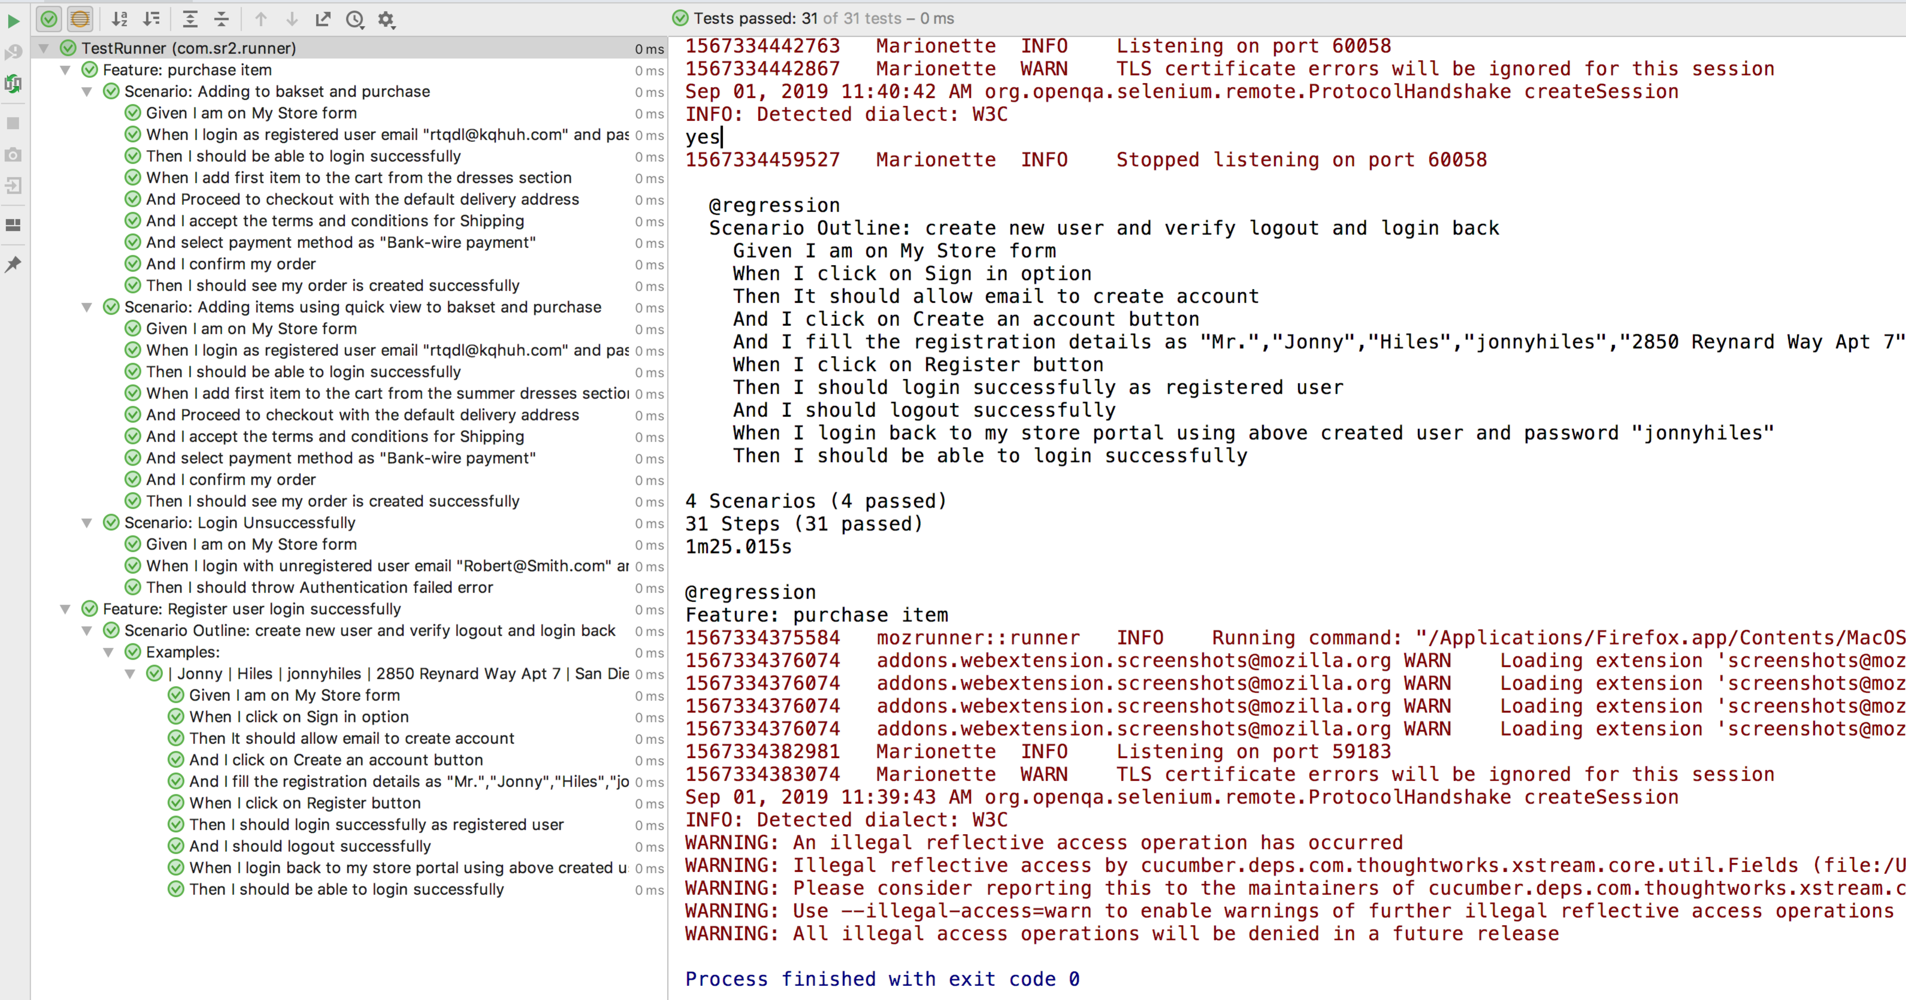

**Note: I have used geckodriver (which is placed in test resources) running scripts on firefox browser (version: 68.0.2 (64-bit)**

**Cucumber Report:**

